**Manual executions**

Graph:

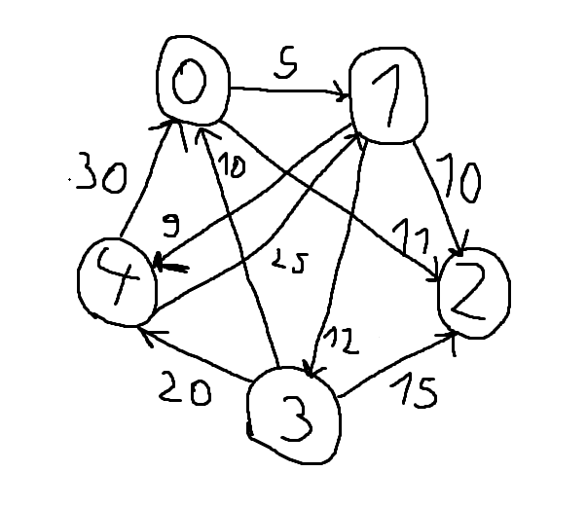

Djikstra’s algorithm:

- the minimum cost walk from a vertex s to all the other vertices

- graph with non-negative costs

s=0, t=4

|  |  |  |  |  |  |
| --- | --- | --- | --- | --- | --- |
|  | x | y | dist: dictionary | q: priority queue | prev: dictionary |
| initialization |  |  | 0   |  |  | | --- | --- | | 0 |  | | <-|(0,0)|<- |  |
| iteration 1  iteration 1.1  iteration 1.2 | 0 | 1  2 | 0 1   |  |  | | --- | --- | | 0 | 5 |   0 1 2   |  |  |  | | --- | --- | --- | | 0 | 5 | 11 | | |  | | --- | |  |   <-|(1,5)|<-  <-|(1,5)|(2,11)|<- | 1   |  |  | | --- | --- | | 0 |  |   1 2   |  |  | | --- | --- | | 0 | 0 | |
| iteration 2  iteration 2.1  iteration 2.2  iteration 2.3 | 1 | 2  3  4 | 0 1 2   |  |  |  | | --- | --- | --- | | 0 | 5 | 11 |   0 1 2 3   |  |  |  |  | | --- | --- | --- | --- | | 0 | 5 | 11 | 17 |   0 1 2 3 4   |  |  |  |  |  | | --- | --- | --- | --- | --- | | 0 | 5 | 11 | 17 | 14 | | <-|(2,11)|<-  <-|(2,11)|<-  <-|(2,11)|(3,17)|<-  <-|(2,11)|(4,14)|(3,17)|<- | 1 2 3   |  |  |  | | --- | --- | --- | | 0 | 0 | 1 |   1 2 3 4   |  |  |  |  | | --- | --- | --- | --- | | 0 | 0 | 1 | 1 | |
| iteration 3 | 2 |  |  | <-|(4,14)|(3,17)|<- |  |
| Iteration 4 | 4 |  |  |  |  |

The minimum cost walk from s=0 to t=4 is built backwards from prev:

t=4; prev[4] = 1; prev[1] = 0 = s

0->1->4, cost = dist[4] = 14

s=2; t=3

|  |  |  |  |  |  |
| --- | --- | --- | --- | --- | --- |
|  | x | y | dist: dictionary | q: priority queue | prev: dictionary |
| initialization |  |  | 2   |  |  | | --- | --- | | 0 |  | | <-|(2,0)|<- |  |
| iteration 1 | 2 |  |  |  |  |

There is no walk from 2 to 3, because 2’s outer degree is 0.